SIMATSENGINEERING(SAVEETHASCHOOLOFENGINEERING)
DepartmentofArtificialIntelligenceandDataScience
ASSESSMENTTOOL1–ANALYTICALPROBLEMSOLVING

CourseCode: | DSA03 | CourseTitle: | NaturalLanguageProcessing
COAssessed: | CO2 – Manipulation | Assessment: | AssessmentTool1–ANALYTICAL PROBLEM SOLVING
Weightage: | 35% ofCIA
CO2Statement: | Designinflectional,derivational,finite-stateparsing,stemmingalgorithmsandforanalyse morphological methods. (BL-3)
Student Name: | K.Yaswanth | Reg. No.: | 192425393
Section/Batch: | SlotD-2024 | Date: | 05/08/2026
CodeofConduct IK.Yaswanth/192425393)(Name/RegNo)certifythatthissubmissionismyoriginalworkandthatIhave adhered to the guidelines specified for this assessment. I understand that any violation of academic integrity rules will result in disciplinary action.
SignatureoftheStudent:K.Yaswanth
Instructions
- Readallquestionscarefullybeforeattemptingtheanswers.
- Answerallfivequestions.Eachquestioncarriesequalmarks.
- Showallintermediatesteps,calculations,probabilitycomputations,taggingdecisions,andjustifications wherever applicable.
- Duration:30minutes.

Section/Topic | Focus | QNos
EnglishWordClasses,PartofSpeech Tagging | Morphologicaldecompositionofconnected,connecting, and connection; identification of roots, suffixes, inflectionalvs.derivationalforms,andnormalizationfor document indexing. | Q1
EnglishWordClasses,TagsetsforEnglish, Rule-Based Part of Speech Tagging | Morphological parsing of unhappy, happiness, and happily; identification of prefixes, suffixes, base forms, and semantic effects of derivational morphology. | Q2
CountingWords,PartofSpeechTagging, English Word Classes | Stemming and root extraction for played, player, and playing; handling grammatical variations and word formation changes for search preprocessing. | Q3
Finite-StateMorphologicalAnalysis,Rule-Based Part of Speech Tagging, Transformation-Based Tagging | Finite-state parsing of writes, writing, and written; modelingregularandirregular verb inflections androot normalization. | Q4
EnglishWordClasses,Rule-BasedPartof Speech Tagging, Counting Words | Porter Stemmer-based processing ofrelational,relation, andrelate;applicationofderivationalsuffixremovaland stem extraction for retrieval. | Q5

AnnexureA–ANALYTICALPROBLEMSOLVING

Given the input words: “connected”, “connecting”, “connection”, design a morphological analysis pipeline for a document indexing system.
  - Applyrulestodecomposeeachwordintorootandsuffixcomponents.
  - Differentiatebetweeninflectionalandderivationalformswithinthedataset.
  - Normalizeallvariantstoacommonbaseformforefficientretrieval.
  - Determinetheparsedstructureandnormalizedoutputforeachword.
  - Write a Python program to implement the above morphological analysis pipeline. The programshouldacceptthegiveninputwords,performdecomposition,classifyeachsuffix as inflectional or derivational, normalize the words to their common base form, and display the parsed structure and normalized output in a tabular format.

Giventheinputwords:“unhappy”,“happiness”,“happily”,designamorphological parsing module for sentiment analysis.
  - Identifyprefixes,suffixes,andbaseformsusingrule-baseddecomposition.
  - Ensuresemanticconsistencyacrossderivedwordforms.
  - Classifyeachtransformationasinflectionalorderivational.
  - Producetherootandmorphologicalbreakdownforeachword.
  - Write a Python program to implement the above morphological parsing module. The program should accept the given input words, identify the prefixes, suffixes, and base forms, classify each transformation as inflectional or derivational, and display the morphological breakdown and normalized root word in a tabular format.

Giventheinputwords:“played”,“player”,“playing”,designastemming-basedpreprocessing module for a search engine.
  - Applymorphologicalrulestostripaffixesandidentifythebaseform.
  - Handlebothgrammaticalvariationsandwordformationchanges.
  - Ensureconsistentrootextractionacrossallforms.
  - Determinethestemandclassificationforeachinputword.
  - DevelopaPythonprogramforastemming-basedpreprocessingmoduleusedinasearch engine. The program should process the input words"played","player","playing"by applying appropriate stemming rules to remove prefixes/suffixes where applicable, identify the stem of each word, distinguish between grammatical inflections and word-formationchanges,andgenerateastructuredoutputshowingtheoriginalword,extracted stem, removed affix (if any), transformation type (inflectional/derivational), and the final normalized form suitable for indexing and information retrieval.

Given the input words: “writes”, “writing”, “written”, design a finite-state morphological parsing module for a text processing system.
  - Applystatetransitionstorepresentsuffixtransformationsandirregularformsinverb inflection.
  - Differentiatebetweenregularandirregularinflectionalpatternswithinthedataset.
  - Ensureconsistentmappingofallformstoacommonrootrepresentation.
  - Determine the state transitions, morphological breakdown, and normalized output for each word.
  - Develop a Python program that implements a finite-state morphological parser for the input words"writes","writing","written". The program should construct a finite-state transition model to process regular suffixes and irregular verb forms, identify the corresponding root word, classify each inputas a regular orirregularinflection,trace the

sequence of state transitions during parsing, and display the state transition path, morphologicalcomponents,rootform,andnormalizedrepresentationforeachinputword in a well-formatted output.

Giventheinputwords:“relational”,“relation”,“relate”,designaPorterStemmer-based preprocessing module for document retrieval.
  - Applystemmingrulesstep-by-steptoremovederivationalsuffixesandobtainbaseforms.
  - Handlevariationsinsuffixpatternswhilepreservingsemanticconsistency.
  - Ensureuniformrootextractionacrossallderivedforms.
  - Determinethestemmingsteps,intermediateforms,andfinalstemforeachinputword.
  - Develop a Python program that implements the Porter Stemming algorithm for the input words"relational","relation","relate". The program should apply the Porter stemming rulessequentiallytoremovederivationalsuffixes,displaytheintermediateformobtained after each stemming step, handle different suffix patterns while preserving the word meaning, and generate the final stem for each word. The output should clearly present theoriginalword,appliedstemmingrule(s),intermediateforms,andthefinal normalized stem in a structured format suitable for document retrieval applications.

RubricsforCalculation

NumericalProblems
Criteria | Weightag e | Level 4 (Exemplary) | Level 3 (Proficient) | Level 2 (Developing) | Level 1 (Beginning)
Problem Understa nding | 20% | Clearly interprets problem,identifies allparametersand requirements accurately | Understands problemwithminor gaps | Partial understanding; misses key elements | Misinterprets or unable to understand problem
Method Selection | 20% | Selects most appropriate method/formula with strong justification | Selects correct methodwithminor errors | Inappropriateor partially correct method | Unable to selectmethod
Solution Process | 25% | Logical,systematic steps with correct approach throughout | Mostly correct stepswithminor mistakes | Disorganizedsteps; multiple errors | Noclear process
Accuracy of  Calculatio n | 20% | All calculations accurate;correct final answer | Minorcalculation errors | Frequenterrors; incorrect final answer | No valid calculations
Interpreta tion of Results | 15% | Clearlyinterprets resultswithunits and engineering relevance | Basic interpretationwith minor omissions | Limitedorunclear interpretation | No interpretation

Q.No./ Criteria Level | Problem Understanding | Method Selection | Solution Process | Accuracyof Calculation | Interpretation of Results | Sub. Total | Total  %
1 | 4 | 4 | 4 | 3 | 3 | 18 | 92
2 | 4 | 3 | 4 | 4 | 3 | 18
3 | 4 | 4 | 4 | 3 | 4 | 19
4 | 3 | 4 | 3 | 4 | 4 | 18
5 | 4 | 4 | 3 | 4 | 4 | 19

FacultyIn-charge | CourseCoordinator | ProgramDirector
Signature: | Signature: | Signature:
Date: | Date: | Date:

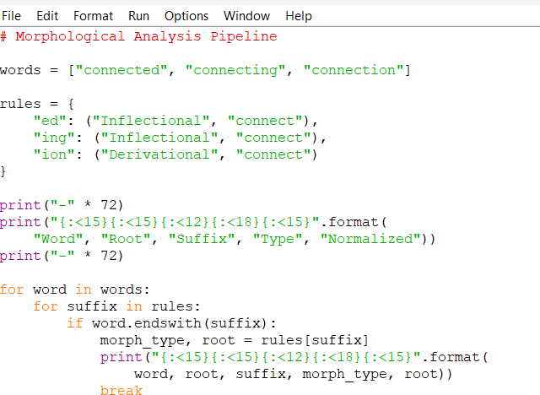
1.

Output
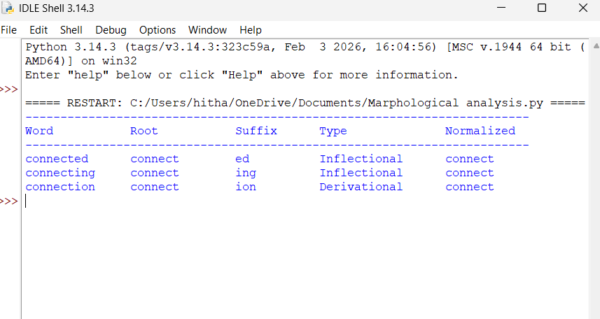

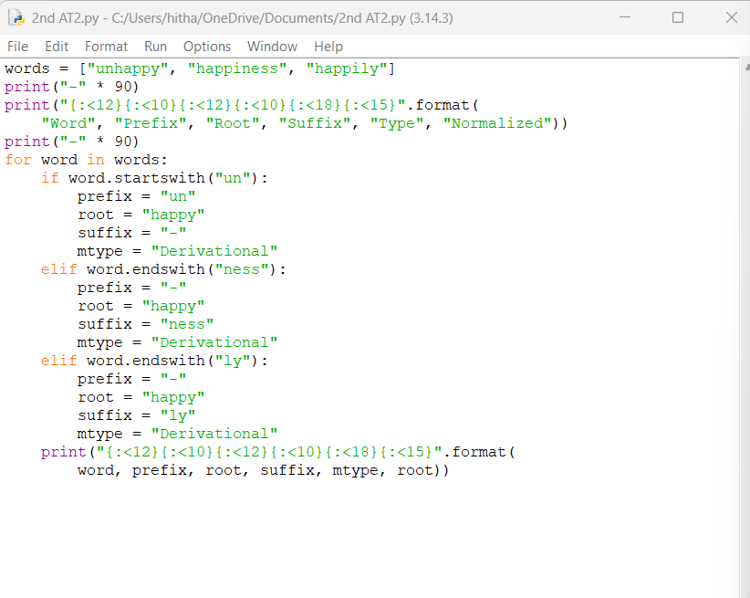
2.

Output

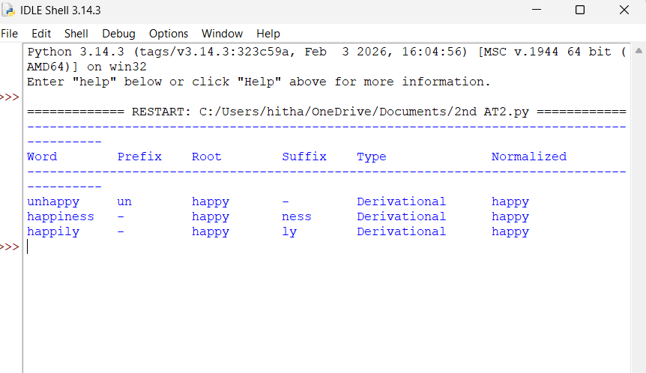

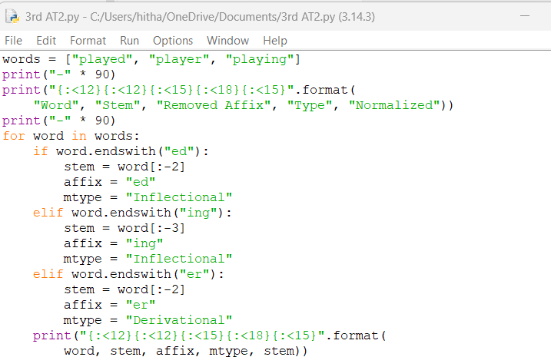
3.

Output

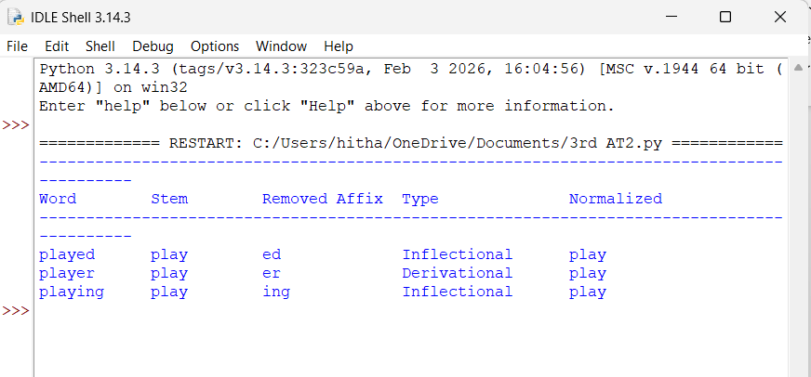

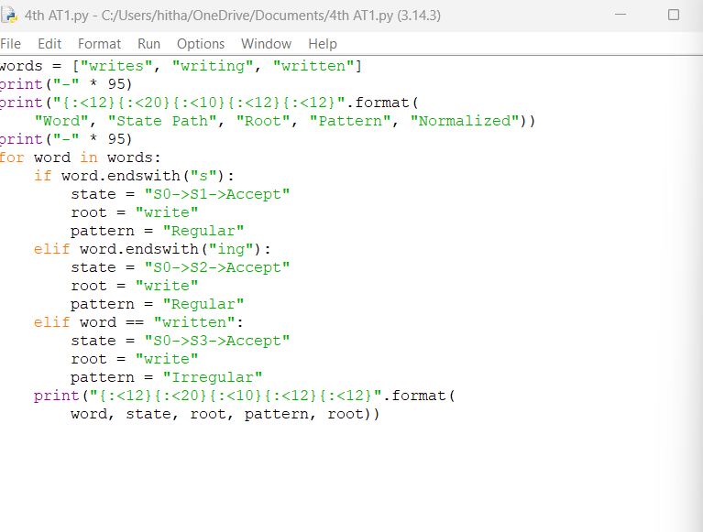
4.

Output:

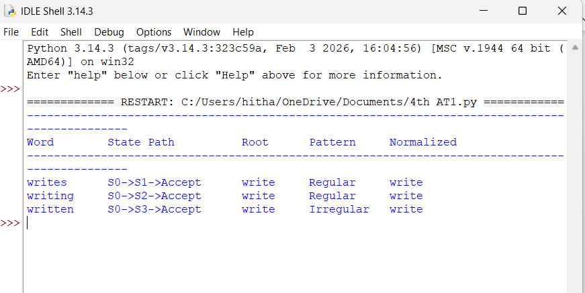

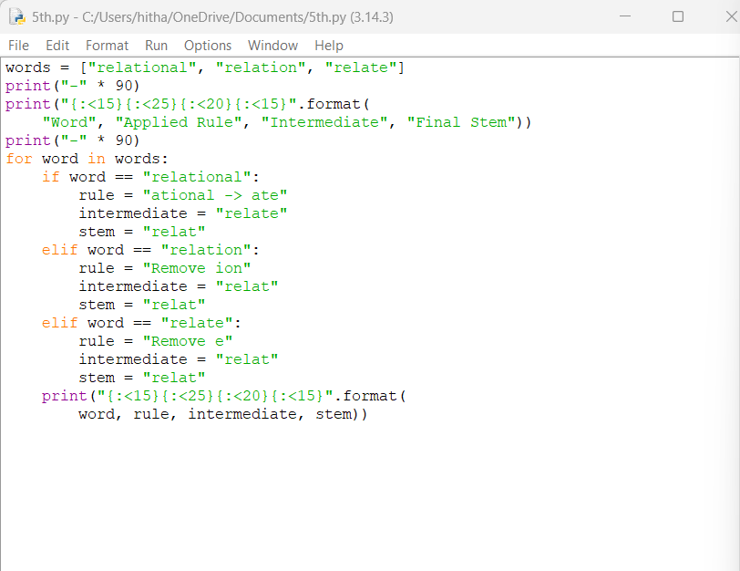
5.

Output:
